|  |  |
| --- | --- |
|  | **DEPARTMENT OF COMPUTER SYSTEMS ENGINEERING**  **MEHRAN UNIVERSITY OF ENGINEERING & TECHNOLOGY, JAMSHORO**  **Database Management Systems (4th Semester) 18CS**  **Lab Experiment 09** |

|  |  |  |  |
| --- | --- | --- | --- |
| **Roll No:** |  | **Date of Conduct:** |  |
| **Submission Date:** |  | **Grade Obtained:** |  |

|  |  |  |  |
| --- | --- | --- | --- |
| **Problem Recognition (0.3)** | **Completeness & accuracy (0.4)** | **Timeliness (0.3)** | **Score (1.0)** |
|  |  |  |  |

**Objective: To understand Indexes, Views & Sequences.**

**Tools: MySQL/Oracle.**

**Introduction:**

**INDEXES:** A database index is a data structure that improves the speed of operations in a table. Indexes can be created using one or more columns. The users cannot see the indexes, they are just used to speed up queries and will be used by the Database Search Engine to locate records very fast.

* The INSERT and UPDATE statements take more time on tables having indexes, whereas the SELECT statements become fast on those tables.
* The reason is that while doing insert or update, a database needs to insert or update the index values as well.

**VIEWS:** In SQL, a view is a virtual table based on the result-set of an SQL statement. A view contains rows and columns, just like a real table. The fields in a view are fields from one or more real tables in the database.

* You can add SQL functions, WHERE, and JOIN statements to a view and present the data as if the data were coming from one single table.
* Note that a view does not physically store the data.

**SEQUENCE:** A sequence is a list of [integers](https://www.mysqltutorial.org/mysql-int/) generated in the ascending order**.** Many applications need sequences to generate unique numbers mainly for identification

**Lab Task**

**1. Create a view called emp_vu based on the employee number, employee name, and department number from the EMP table. Change the heading for the employee name to EMPLOYEE.**

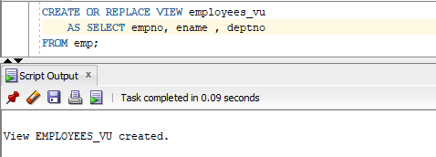**Task**

**2. Display the contents of the EMP_VU view.**

**Task**

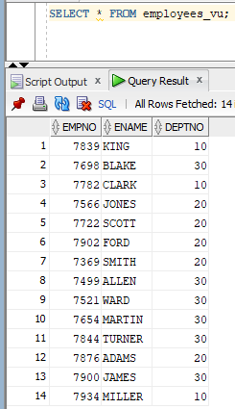

**3. Select the view name and text from the data dictionary USER_views.**

**Task**

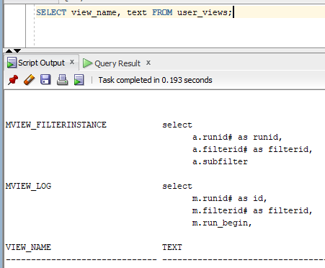

**4. Create a view named DEPT_VU_20 that contains the employee number, employee name and department number for all employees in department 20. Label the view column Employee_Id, Employee, and Department_Id. Do not allow an employee to be reassigned to another department through the view.**

**Task**

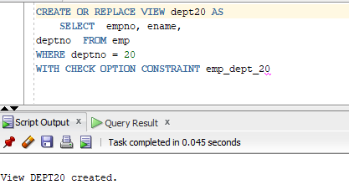

**5. Attempt to reassign Smith to department 30.**

**Task**

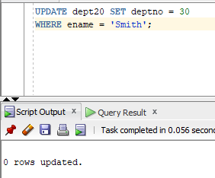

**6. Create a view Salary_vu based on the employee name, department name, salary and salary grade for all employees. Label the columns Employee, Department, Salary and Grade.**

**Task**

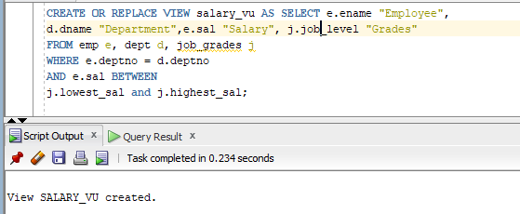

**7. Create a sequence to be used with primary key column of the department table. The sequence should start at 60 and have a maximum value of 200. Have your sequence increment by ten numbers. Name the sequence Dept_Id_Seq.**

**Task**

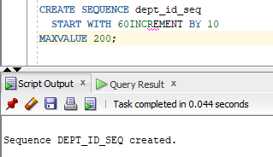

**8. Display the following information about your sequences: sequence name, max value, increment size, and last number.**

**Task**

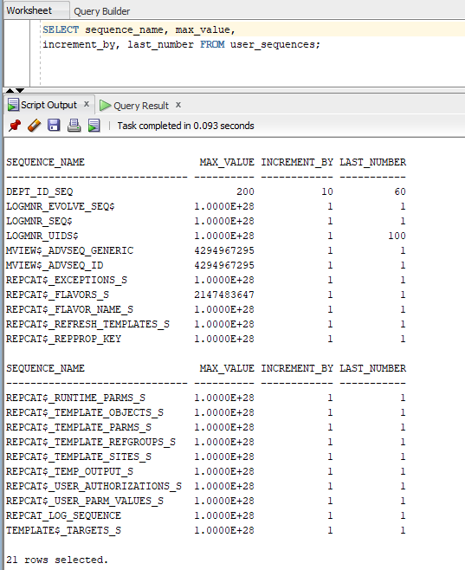

**9. Create a non-unique index on the foreign key column in the employee table.**

**Task**

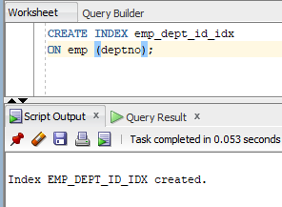

**10. Create a synonym for Dept_Id_Seq.**

**Task**

